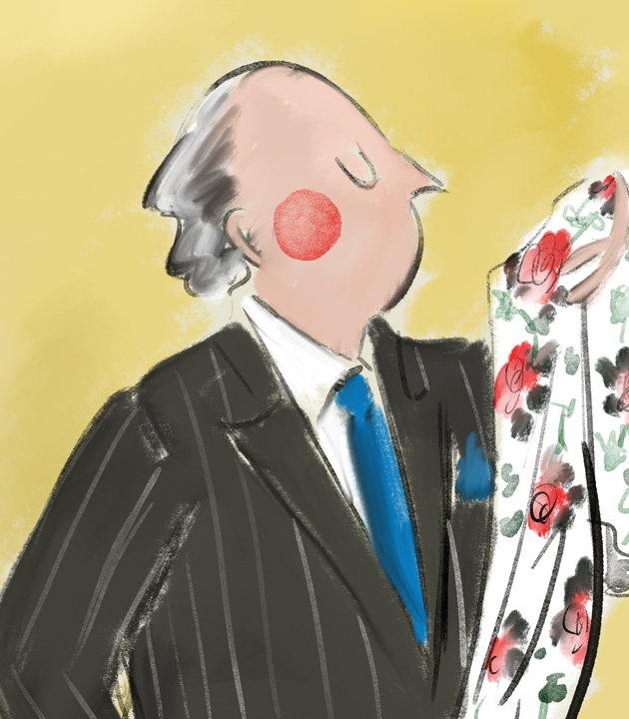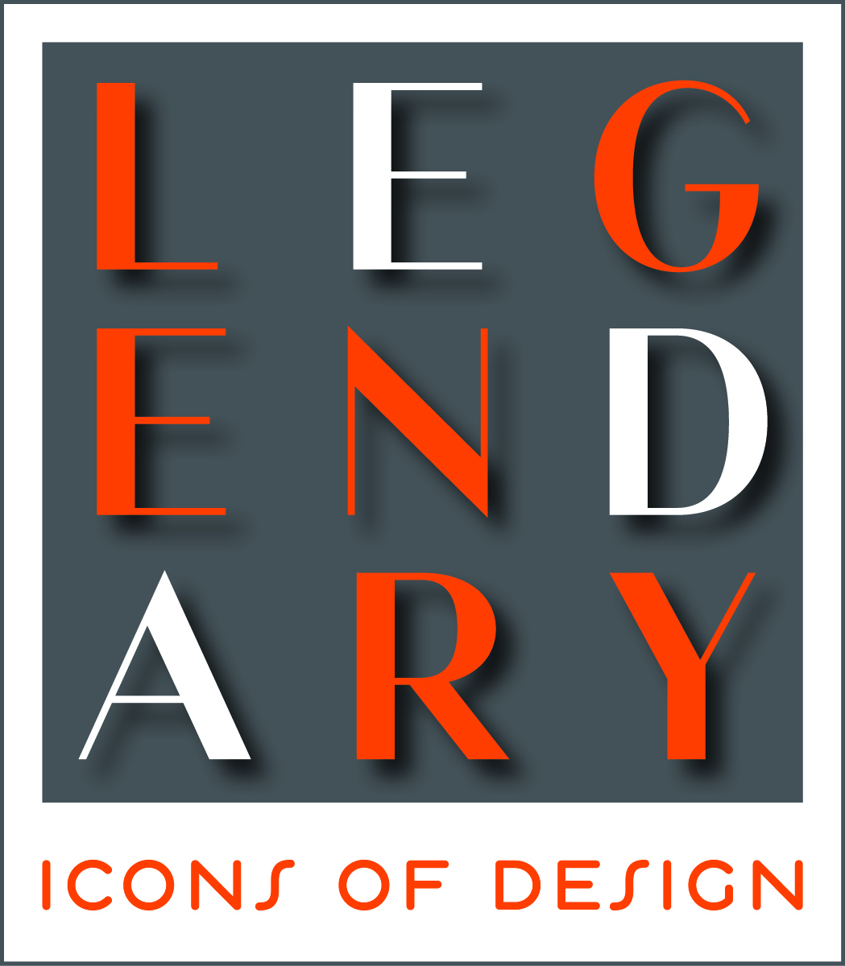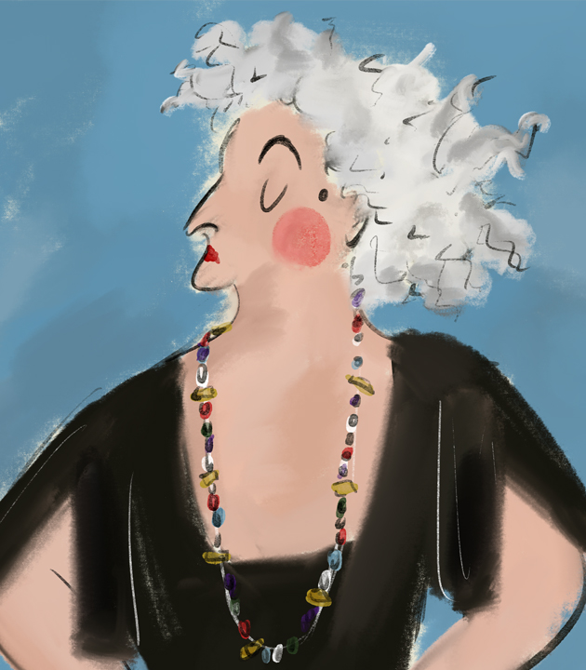

LCDQ’s LEGENDS 2019 to Celebrate Icons of Design

35 of the Brightest Design Stars Already Signed on to Create Window Vignettes

(Los Angeles, February 7, 2019) – What becomes an icon most? Fifty design stars from around the U.S. and the world are going to define that in their own way during the La Cienega Design Quarter’s annual highly acclaimed LEGENDS event, which this year will celebrate the design stars of yesteryear.

The most sought-after event on the national design calendar is set for May 7, 8 and 9, 2019. This year’s theme –Legendary: Icons of Design – is a revival of the very first LEGENDS event in 2009.

True to tradition, the selected interior designers will transform the windows of the 50 LCDQ shop and showroom windows to honor legendary icons such as Albert Hadley, Rose Cummings, David Hicks, Elsie de Wolfe, Mark Hampton, Andree Putman, Billy Baldwin, and Dorothy Draper.

After LCDQ-hosted kick-off parties in New York and in Los Angeles, 35 interior design stars have already committed to creating windows honoring icons of design and only 15 windows are left. Designers from around the U.S. and abroad who will participate in the LEGENDS 2019 windows include Nina Campbell from London, Bunny Williams, Alex Papachristidis, Neal Beckstedt, Sasha Bikoff and Nicole Fuller. Popular Southern California designers such as Jeremiah Brent, Bradley Bayou and Brooke and Steve Giannetti also have signed on to design windows.

The largest event of its kind supported by major corporate sponsors and a dozen media partners, LEGENDS brings thousands of influencers, enthusiasts, top design editors, and purveyors of design from across the U.S. and from around the world to the LCDQ for three days of keynotes, open houses, discussions, book signings, exhibitions, social events and networking.

New features are in store for LEGENDS 2019:

- There will be 3 full days of programming, starting with breakfast and a “Shop the Quarter” day on Tuesday, May 7, with luxury transportation throughout the LCDQ. A scavenger hunt sponsored by Sotheby’s Home to will make the experience all the more fun, followed by the highly sought after “Opening Party” that draws 600 to 800 guests for a celebratory evening.

- Embracing Hollywood and the movie industry, LCDQ will transform the VIP Lounge to a “Green Room” outfitted by Pacific Sales where LEGENDS guests can refresh and recharge their electronic devices.
- Several area hotels will offer discounted rooms for LEGENDS 2019 attendees. Click here to make reservations.
To date, sponsors for LEGENDS 2019 include:
- 1stdibs and Pacific Sales as Partner Sponsors, Benjamin Moore and Sotheby’s Home as Presenting Sponsors, and Chairish and the New York Design Center as Participating Sponsors.
- Media: Elle Decor, Galerie, House Beautiful, Interiors, Luxe Interiors + Design, Traditional Home, Veranda, California Home + Design and California Homes.

Stay tuned for further updates announced via this page and on LCDQ’s social media channels. In the meantime, watch what makes the LEGENDS event so special: http://lcdqla.com/legends-2019/.

For additional announcements regarding LEGENDS 2019, please visit lcdqla.com.

ABOUT LEGENDS: In its 11th consecutive year, LEGENDS has attracted over 70,000 attendees and garnered more than 350 million media impressions in the last year alone. The parties, lunches and programs are a huge draw, with as many as 800 people at the kick-off party in previous years and capacity audiences of 150-250 at the programs held in LCDQ member shops and showrooms.

ABOUT LCDQ: The La Cienega Design Quarter was founded in 2008 to promote the burgeoning antiques and design neighborhood on one of Los Angeles’ oldest thoroughfares. Since the 1950s, La Cienega Boulevard has been the leading destination for interior design, shopped by icons like William Haines, Elsie de Wolfe, Tony Duquette, Frances Elkins, Chet Chidester, Michael Taylor and Kalef Alaton. Today, La Cienega (from Santa Monica Boulevard to Rosewood Avenue), Melrose Avenue (to the East and West) and Melrose Place continue to be the leading destination for high-end design as top designers, celebrities and selective shoppers source the most unique furniture, antiques, lighting, garden, ironwork, hardware, rugs, fabrics, art and accessories in the world from the 50+ shops, galleries and showrooms of the LCDQ. For further information visit www.lcdqla.com.

Media Contact:
Tamar Mashigian
310.276.5001
tamar@cdecor.com

###

